Erin Swinson
CS 360
Dr. Brian Holbert
June 21, 2026
Final Project
App Description
The Weight Tracking App will be introduced in the app store with a description that explains its focus on helping individuals monitor their health through consistent daily tracking. The description will emphasize the secure login system powered by a local SQLite database, ensuring that each user’s data remains private and user/device specific. It will also show the app’s ability to add, edit and delete weight entries simply with no over complicated fluff. The optional SMS reminder system will be described as a supportive tool for users with a specific goal. To visually represent the app, the icon will feature a minimalist counterweight scale with plus and minus signs in each bucket. These represent the simple recording of changes in weight. This icon will remain clear and recognizable at small sizes.
 
Supported Android Versions
The Weight Tracking App will support Android 8.0 and above to ensure compatibility with modern devices. Android 8.0 introduced significant changes to background execution limits, notification behavior, and runtime permission handling, all of which directly affect features used in this app, such as SMS permissions and UI responsiveness (Android Developers, 2023a). Supporting newer versions also ensures stable performance for components like RecyclerView and SQLite database operations, which rely on updated system libraries and optimized memory management. Each Android release introduces new behavioral restrictions, including ones that will impact the SMS access, so the app needs to have been tested on multiple emulator configurations to confirm consistent behavior across versions (Android Developers, 2023b).
App Permissions
The Weight Tracking App follows a minimal permissions approach to protect user privacy and comply with modern Android security expectations. The only permission requested is SEND_SMS, which is required for the optional SMS reminder feature. This permission is requested at runtime and only after the user explicitly chooses to enable reminders, ensuring that the app never accesses messaging capabilities without consent. Features like login, weight history, and goal tracking that works through local SQLite storage do not require access to contacts, location, audio, camera, or network services. This operates within the Google Play’s guidelines for responsible permission usage.
Monetization Strategy
Since the Weight Tracking App is entering a highly competitive space where many established fitness and weight‑tracking apps already offer extensive features at no cost, the most realistic and sustainable monetization strategy is to rely on internal advertising rather than paid upgrades or subscription models. The app’s primary advantage is its simplicity but that alone does not motivate users to pay when alternative apps provide advanced analytics, cloud syncing, and unique educational content. Introducing a paywall would likely discourage adoption, especially for new users who are comparing multiple apps before committing. Instead, lightweight, non‑intrusive banner ads placed at the bottom of the weight history screen or on the login page would allow the app to generate revenue without disrupting the user experience. This keeps the core functionality free and accessible while still providing a path for financial sustainability. As the user base grows, ad performance scales, allowing the app to remain simple, free, and competitive in a crowded marketplace.
Screen Shots
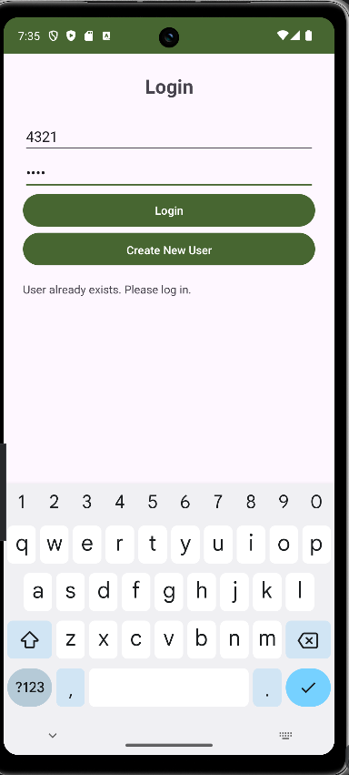 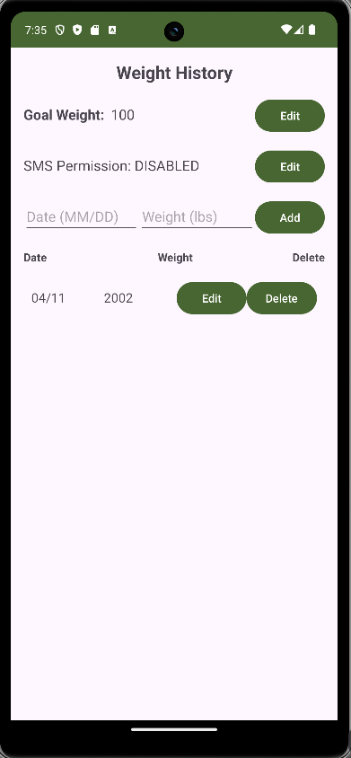 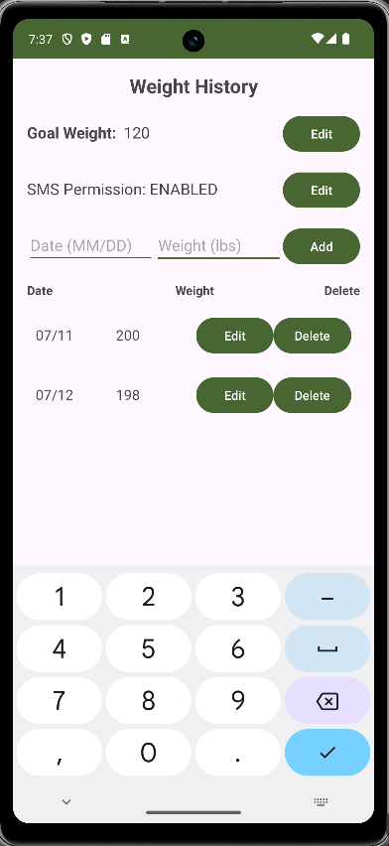
References
Android Developers. (2023a). Behavior changes: Apps targeting Android 8.0 (API level 26). Google. https://developer.android.com/about/versions/oreo/android-8.0-changes
Android Developers. (2023b). Permissions overview. Google. https://developer.android.com/guide/topics/permissions/overview

